Name: Bradley Willcott

ID: M198449

Date: 2 November 2021

Assessment Task (AT 2.4)

Jupiter Mining Corporation

Contents

Figures 2

Debugging 3

Testing 4

References 29

Tables

Table 1: Testing results 4

# Figures

Figure 1 – Showing the response from the server 3

Figure 2 - Socket Server started 5

Figure 3 – GUI program started 6

Figure 4 – Display Help/About - A 7

Figure 5 – Display Help/About – B 7

Figure 6 – Help/Log Console - A 8

Figure 7 – Help/Log Console B (Open) 9

Figure 8 – Help/Log Console – C (Show updated menu) 10

Figure 9 – User/New Account - A 11

Figure 10 – User/New Account – B (New Account form) 12

Figure 11 – User/New Account – C (Results) 13

Figure 12 – Chat session - A 14

Figure 13 – Chat session - B 15

Figure 14 – Chat/Logout - A 16

Figure 15 – Chat/Logout - B 17

Figure 16 – Chat/Login - A 18

Figure 17 – Chat/Login – B (Login form) 19

Figure 18 – Chat/Login – C (Chat session open) 20

Figure 19 – Try to add new user with no password – A (New Account form) 21

Figure 20 - Try to add new user with no password – B (Result: Failed) 22

Figure 21 – Try to login as non-existent user - A (Login form) 23

Figure 22 - Try to login as non-existent user – B (Result: Failed) 24

Figure 23 – Help/Log Console – A (Close) 25

Figure 24 – Help/Log Console - B (Closed) 26

Figure 25 – File/Exit - A 27

Figure 26 – File/Exit - B (Program shutdown) 28

# Debugging

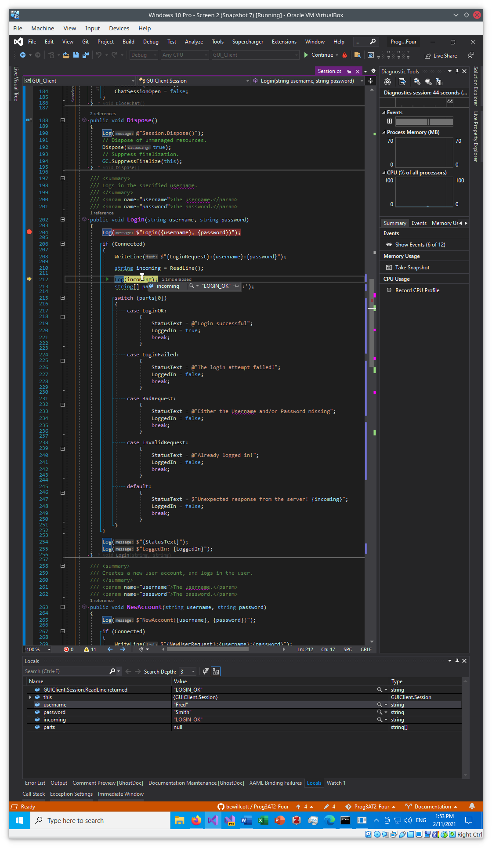

Figure – Showing the response from the server

# Testing

Table 1: Testing results

|  |  |  |  |  |
| --- | --- | --- | --- | --- |
| Case | Description | Expected | Actual | Evidence |
| #1 | Start Socket Server | Displays opening title and status messages | As expected | Figure 2 |
| #2 | Run the GUI program | Display the program | As expected | Figure 3 |
| #3 | Display Help/About | Show dialog box | As expected | Figure 4  Figure 5 |
| #4 | Show Log Console | LogConsole Window open | As expected | Figure 6  Figure 7  Figure 8 |
| #5 | Create a new user account:  User: “Peter”  Password: “Rabbit” | Display New Account form, show process in LogConsole and Command window of Server | As expected | Figure 9  Figure 10  Figure 11 |
| #6 | Show use of Chat session | Show results | As expected | Figure 12  Figure 13 |
| #7 | Log out of Chat session | Back to empty page | As expected | Figure 14  Figure 15 |
| #8 | Login as:  User: “Peter”  Password: “Rabbit” | Display Login form, show process in LogConsole and Command window of Server | As expected | Figure 16  Figure 17  Figure 18 |
| #9 | Try to add new user:  User: “Nutter”  Password: “” | Show results:  Failed to create new account, not logged in | As expected | Figure 19  Figure 20 |
| #10 | Try to Login as:  User: “Nutter”  Password: “” | Show results:  Failed to login | As expected | Figure 21  Figure 22 |
| #11 | Close Log Console | LogConsole hidden | As expected | Figure 23  Figure 24 |
| #12 | File/Exit | Program terminates without complaints. | As expected | Figure 25  Figure 26 |
|  | Check modifications to New Account form processing: |  |  |  |
| #13 | Try to Submit with blank Username | Show error message and highlight Username label | As expected | Figure 27  Figure 28 |
| #14 | Try to submit with blank Password | Show error message and highlight Password label | As expected | Figure 29 |
| #15 | Try to submit without entering the same Password into the second password field | Show error message and highlight Confirm Password label | As expected | Figure 30  Figure 31  Figure 32 |
| #16 | Use Reset button to clear the form | Show all fields empty and labels reset to default color | As expected | Figure 33  Figure 34 |
|  |  |  |  |  |
|  |  |  |  |  |

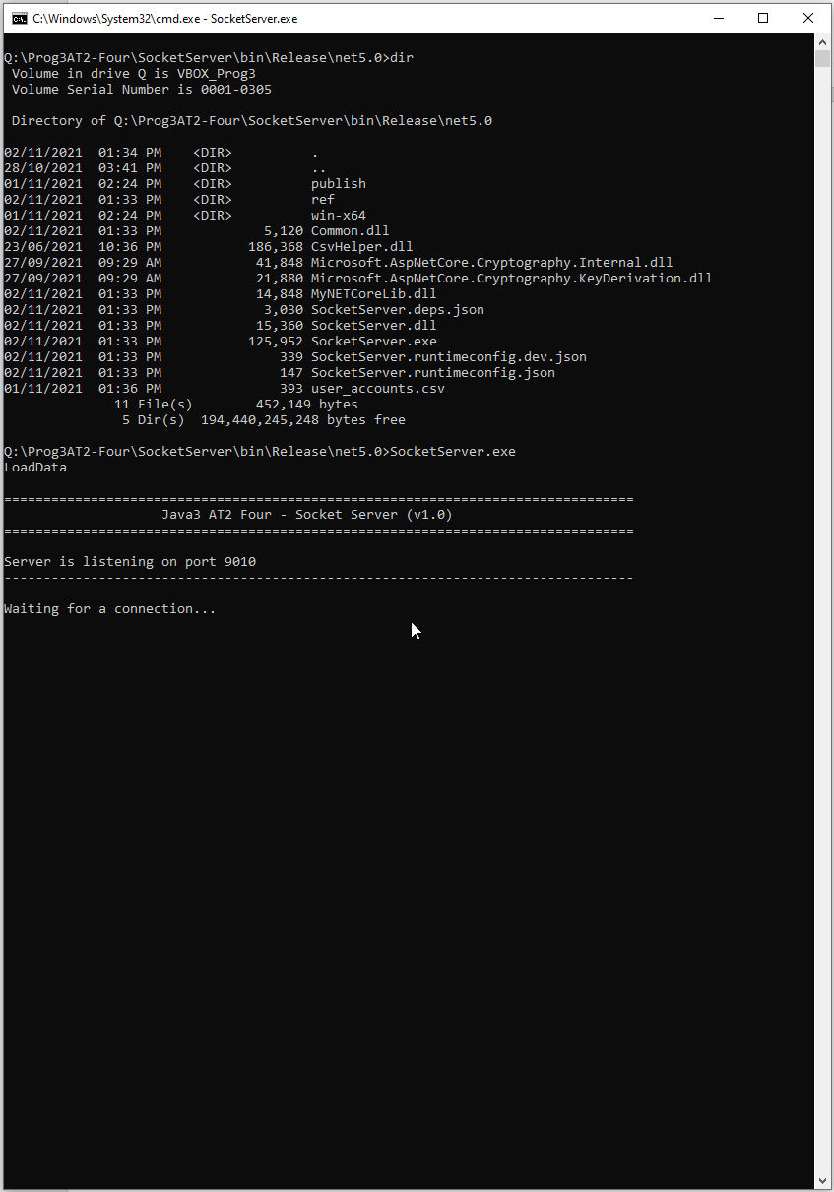

Figure 2 - Socket Server started

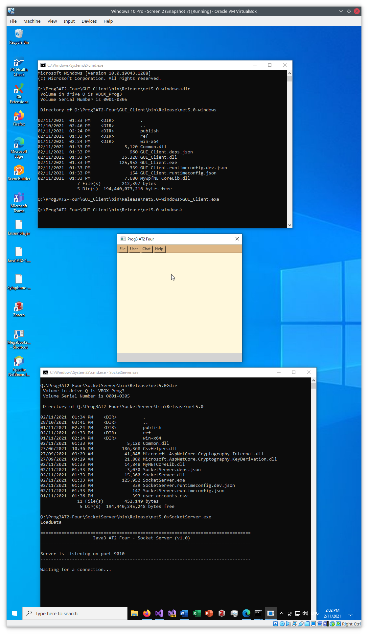

Figure – GUI program started

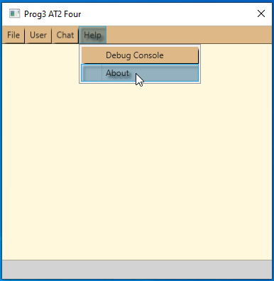

Figure – Display Help/About - A

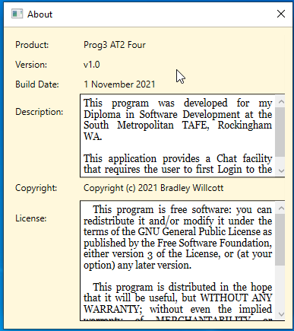

Figure – Display Help/About – B

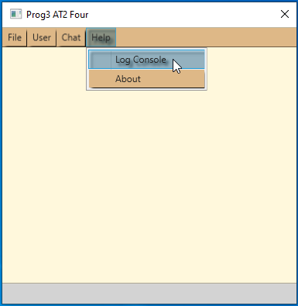

Figure – Help/Log Console - A

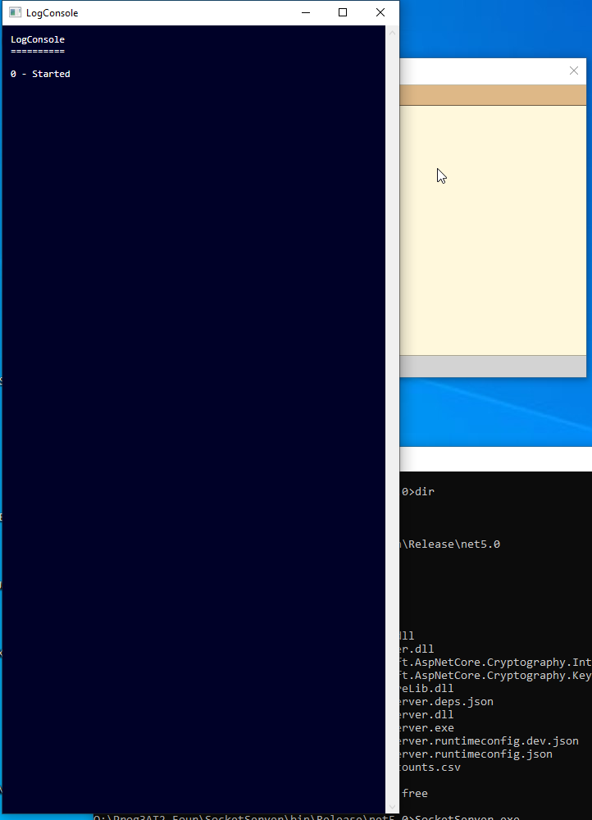

Figure – Help/Log Console B (Open)

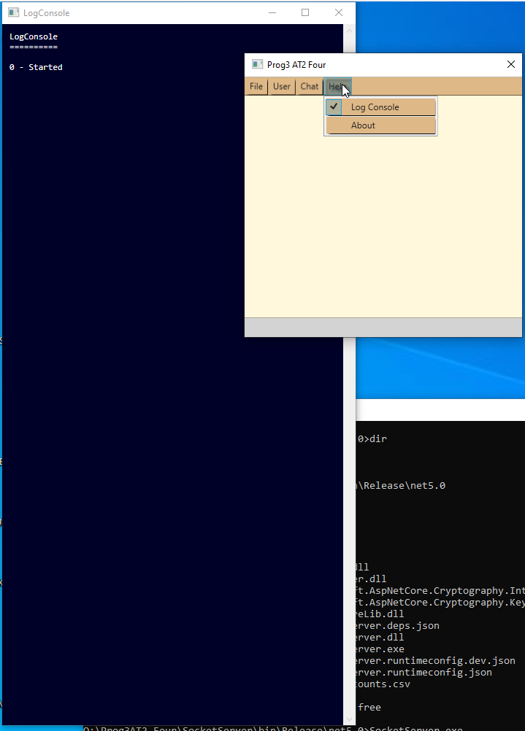

Figure – Help/Log Console – C (Show updated menu)

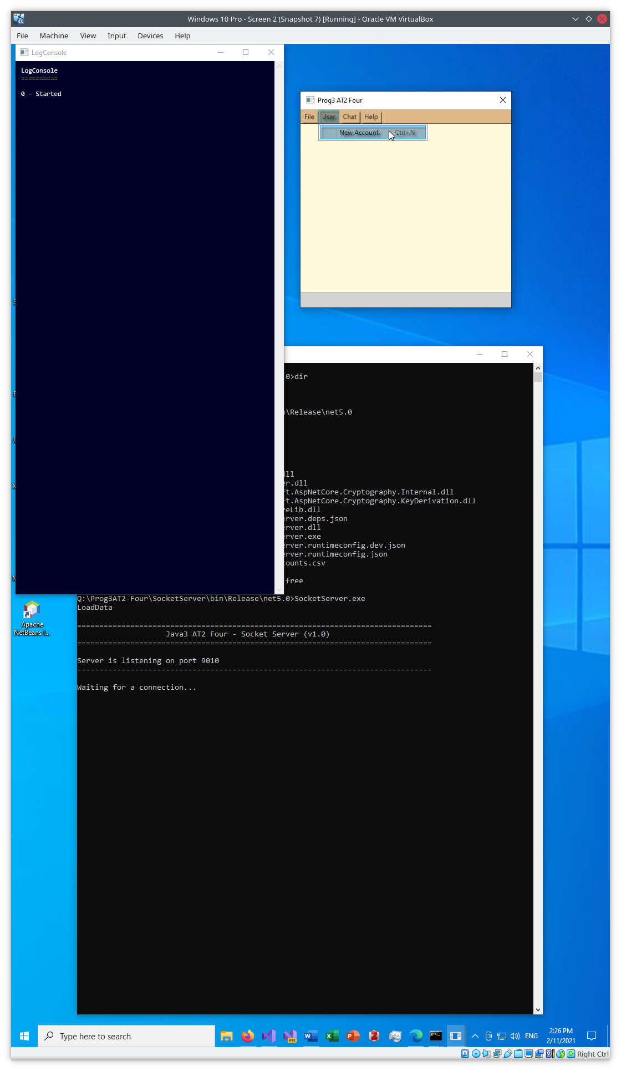

Figure – User/New Account - A

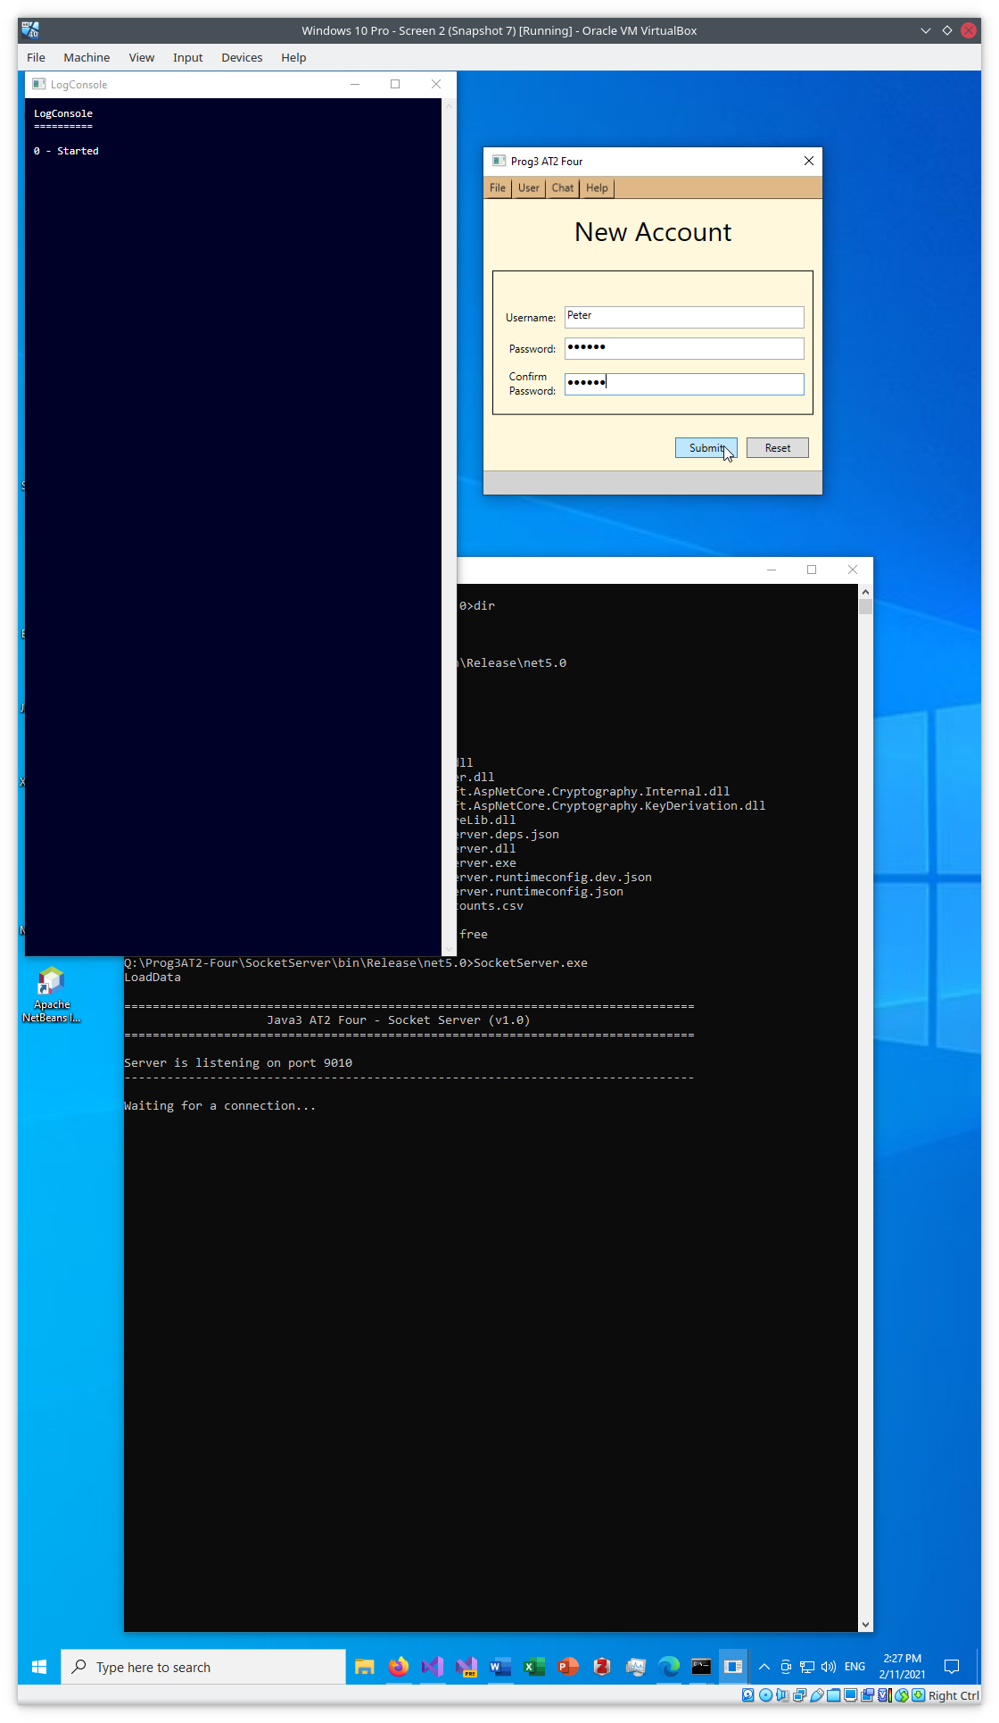

Figure – User/New Account – B (New Account form)

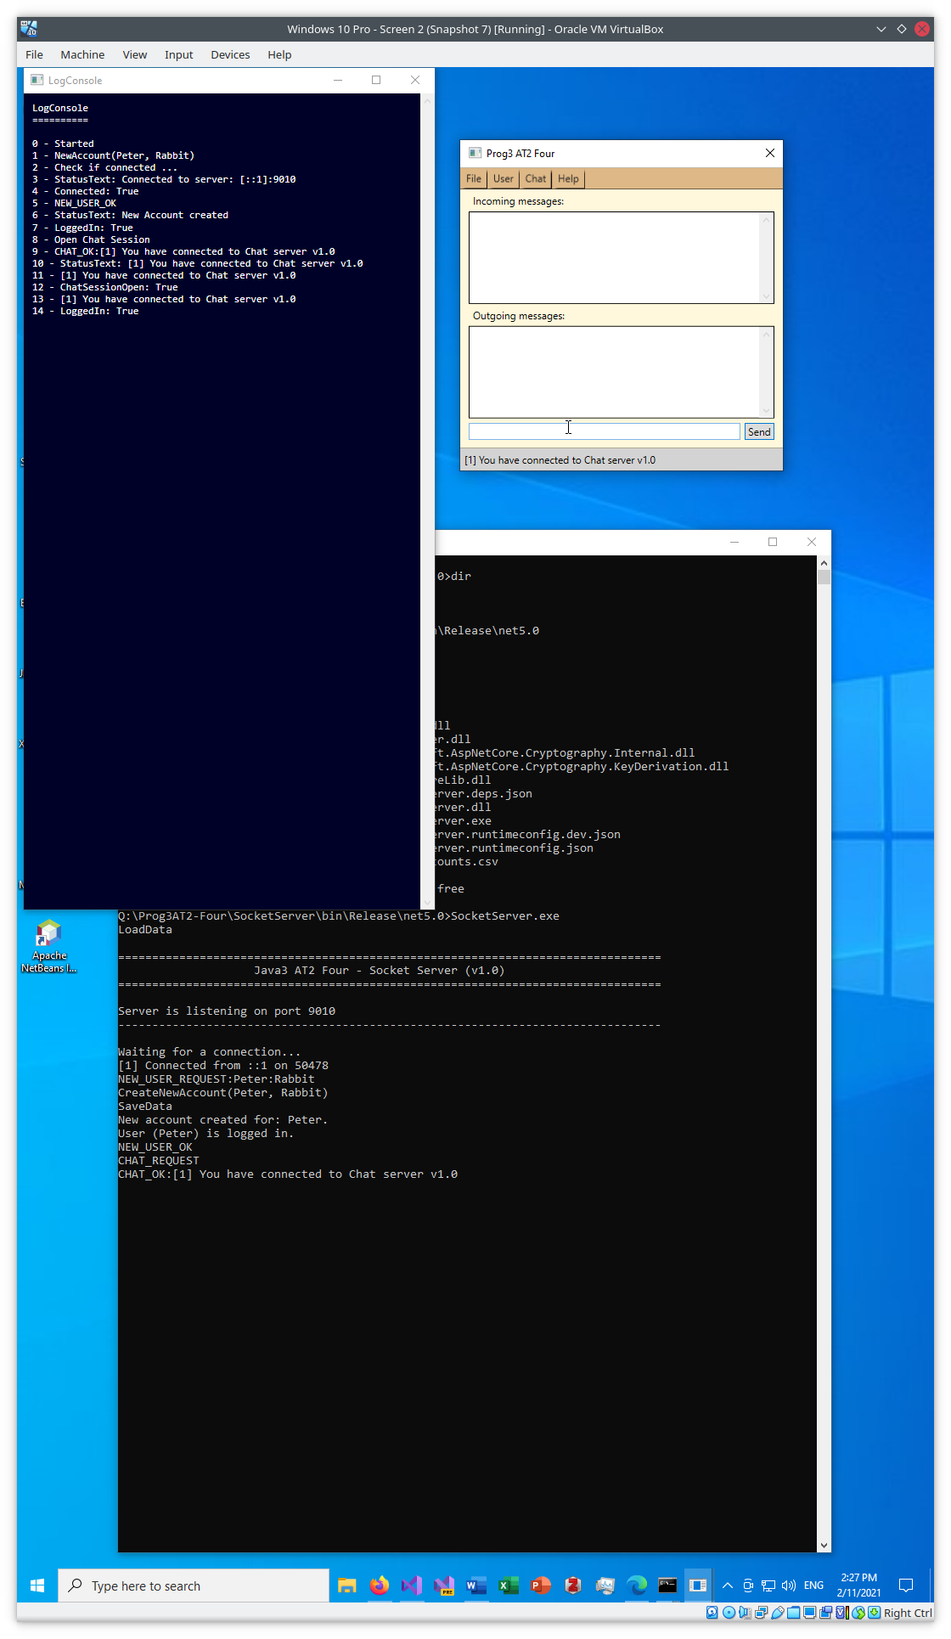

Figure – User/New Account – C (Results)

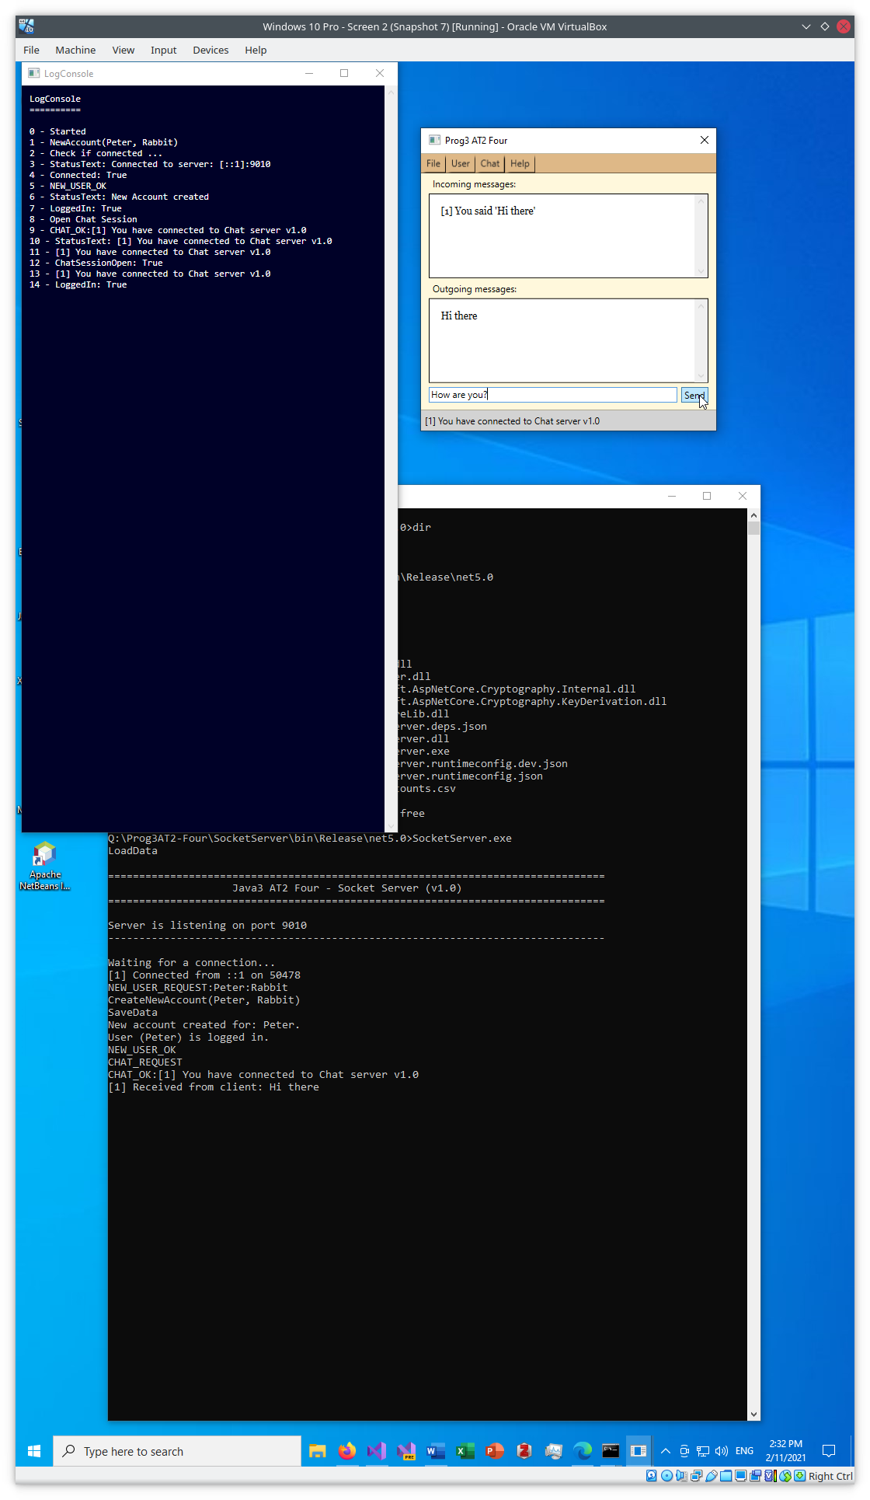

Figure – Chat session - A

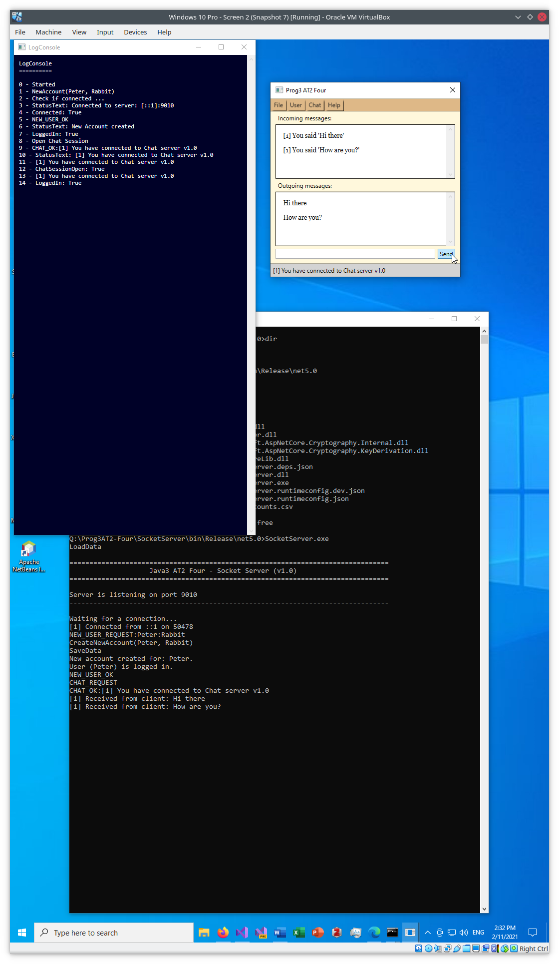

Figure – Chat session - B

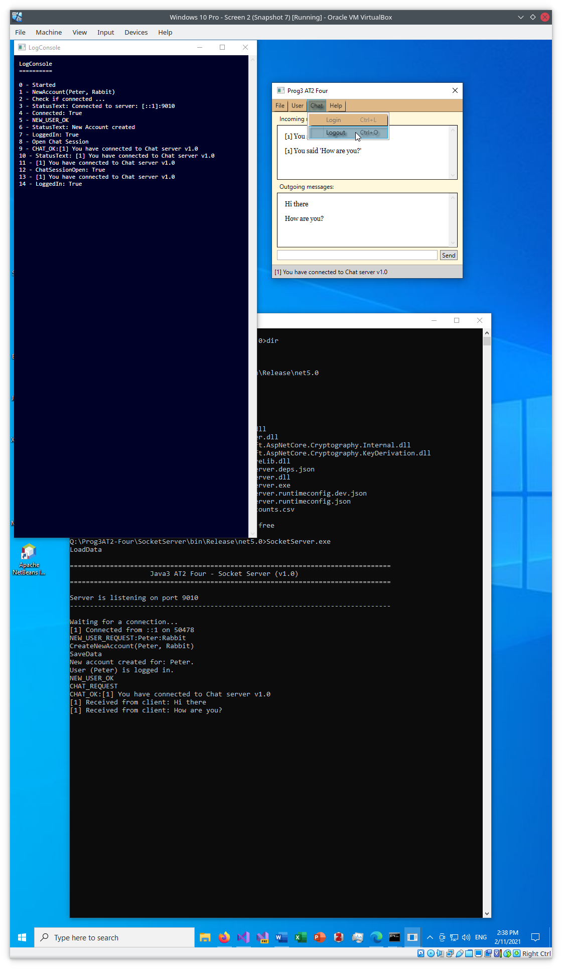

Figure – Chat/Logout - A

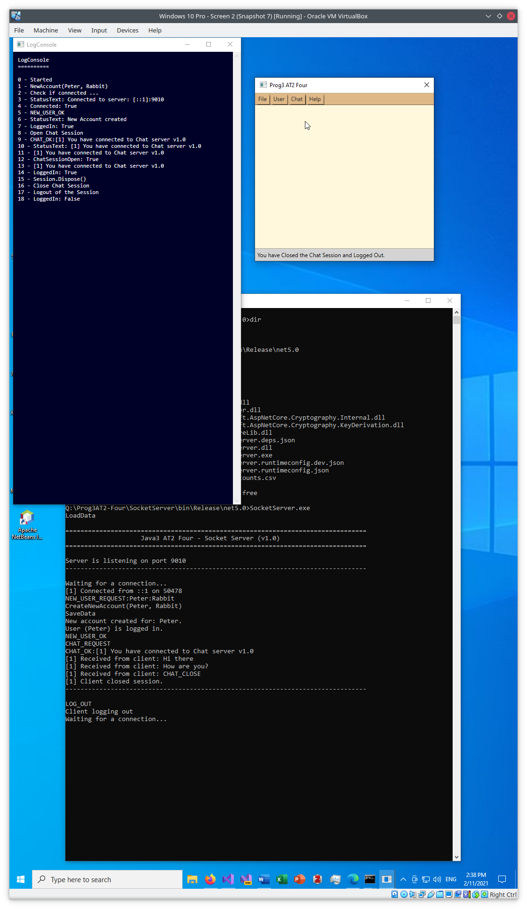

Figure – Chat/Logout - B

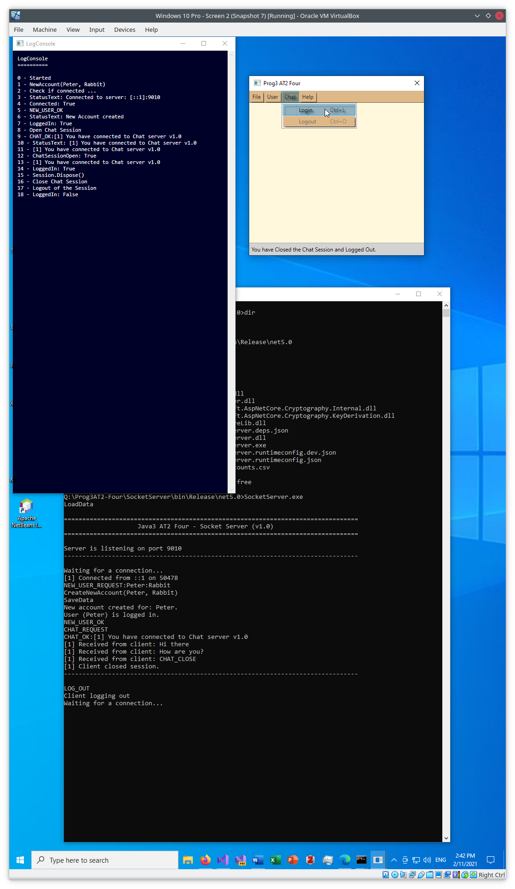

Figure – Chat/Login - A

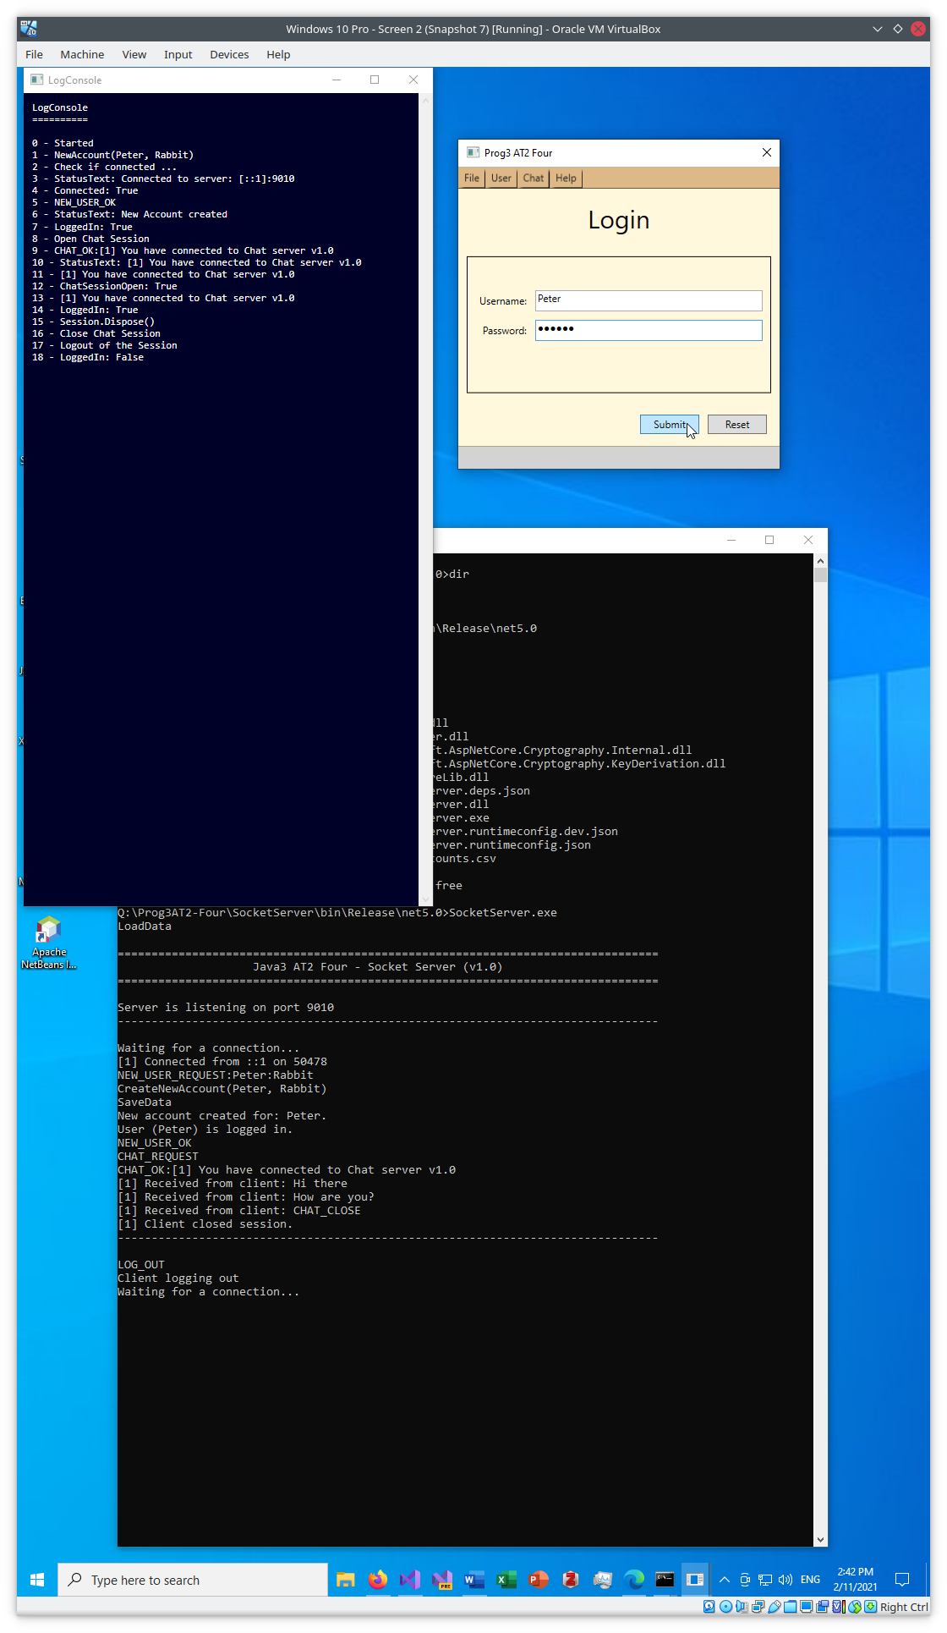

Figure – Chat/Login – B (Login form)

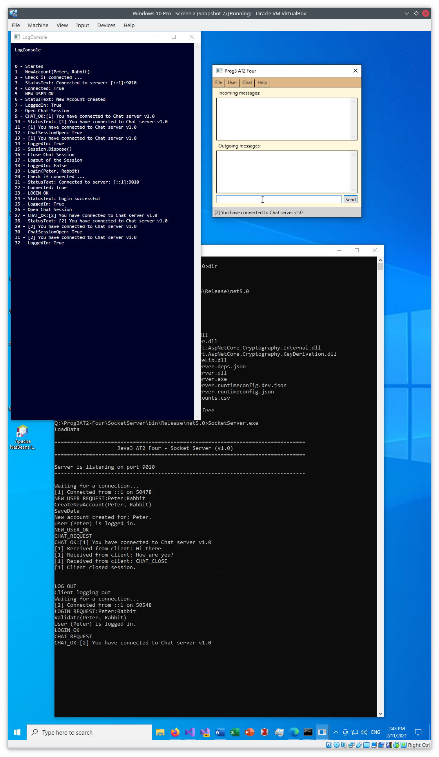

Figure – Chat/Login – C (Chat session open)

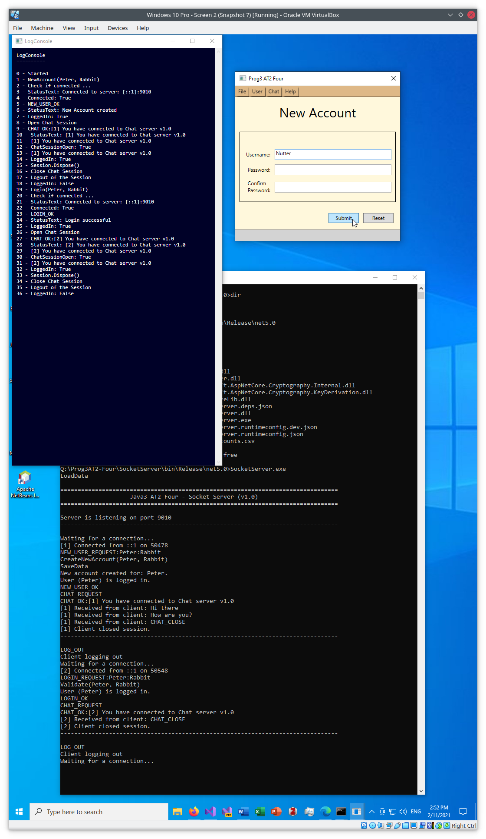

Figure – Try to add new user with no password – A (New Account form)

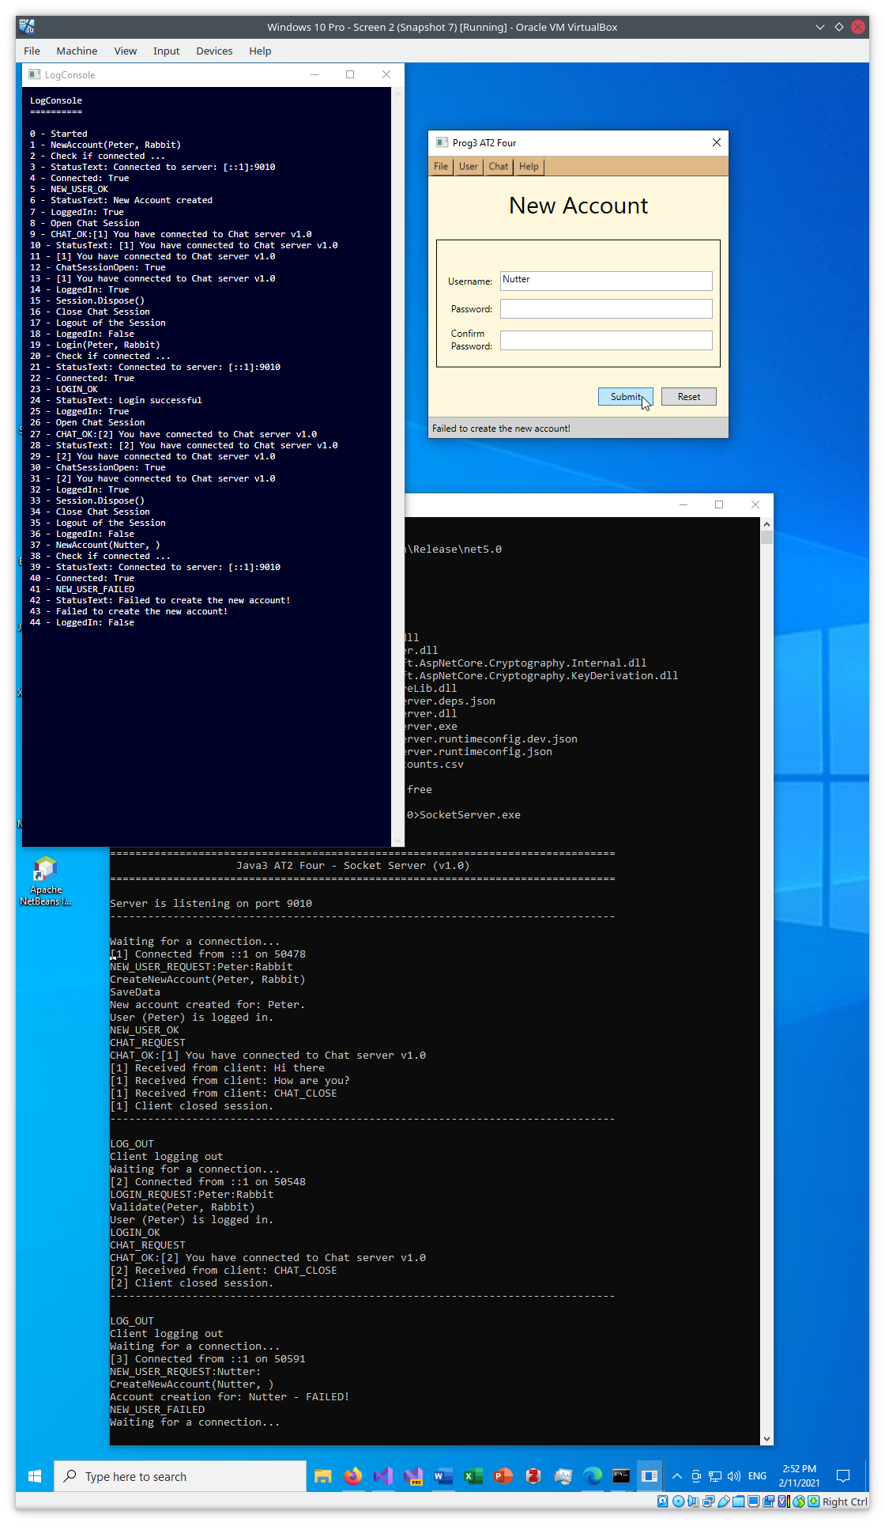

Figure - Try to add new user with no password – B (Result: Failed)

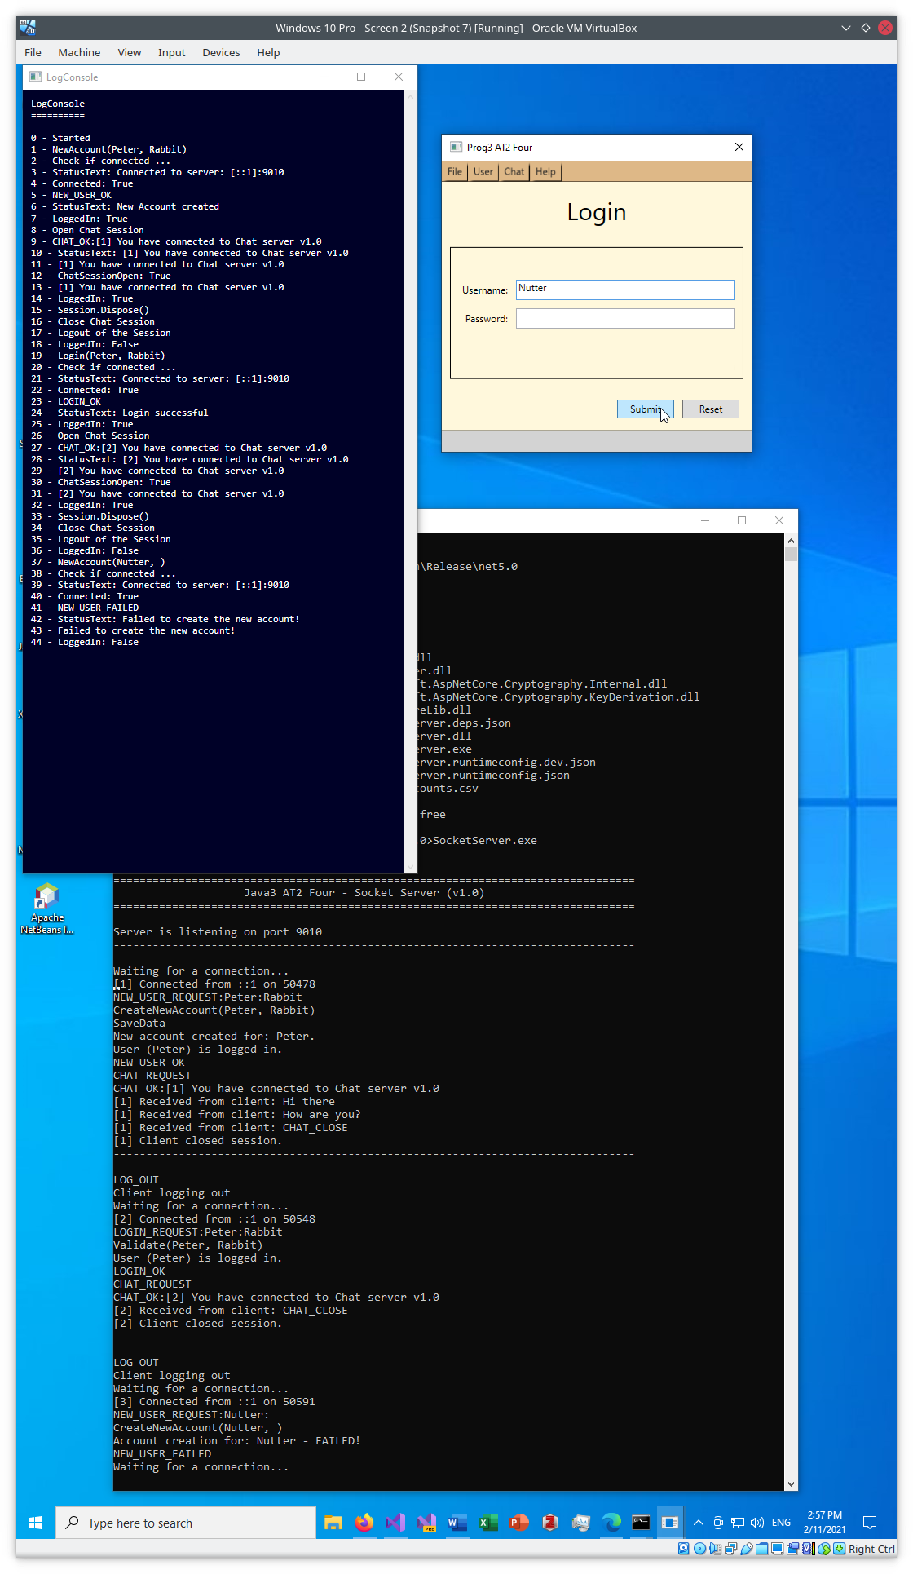

Figure – Try to login as non-existent user - A (Login form)

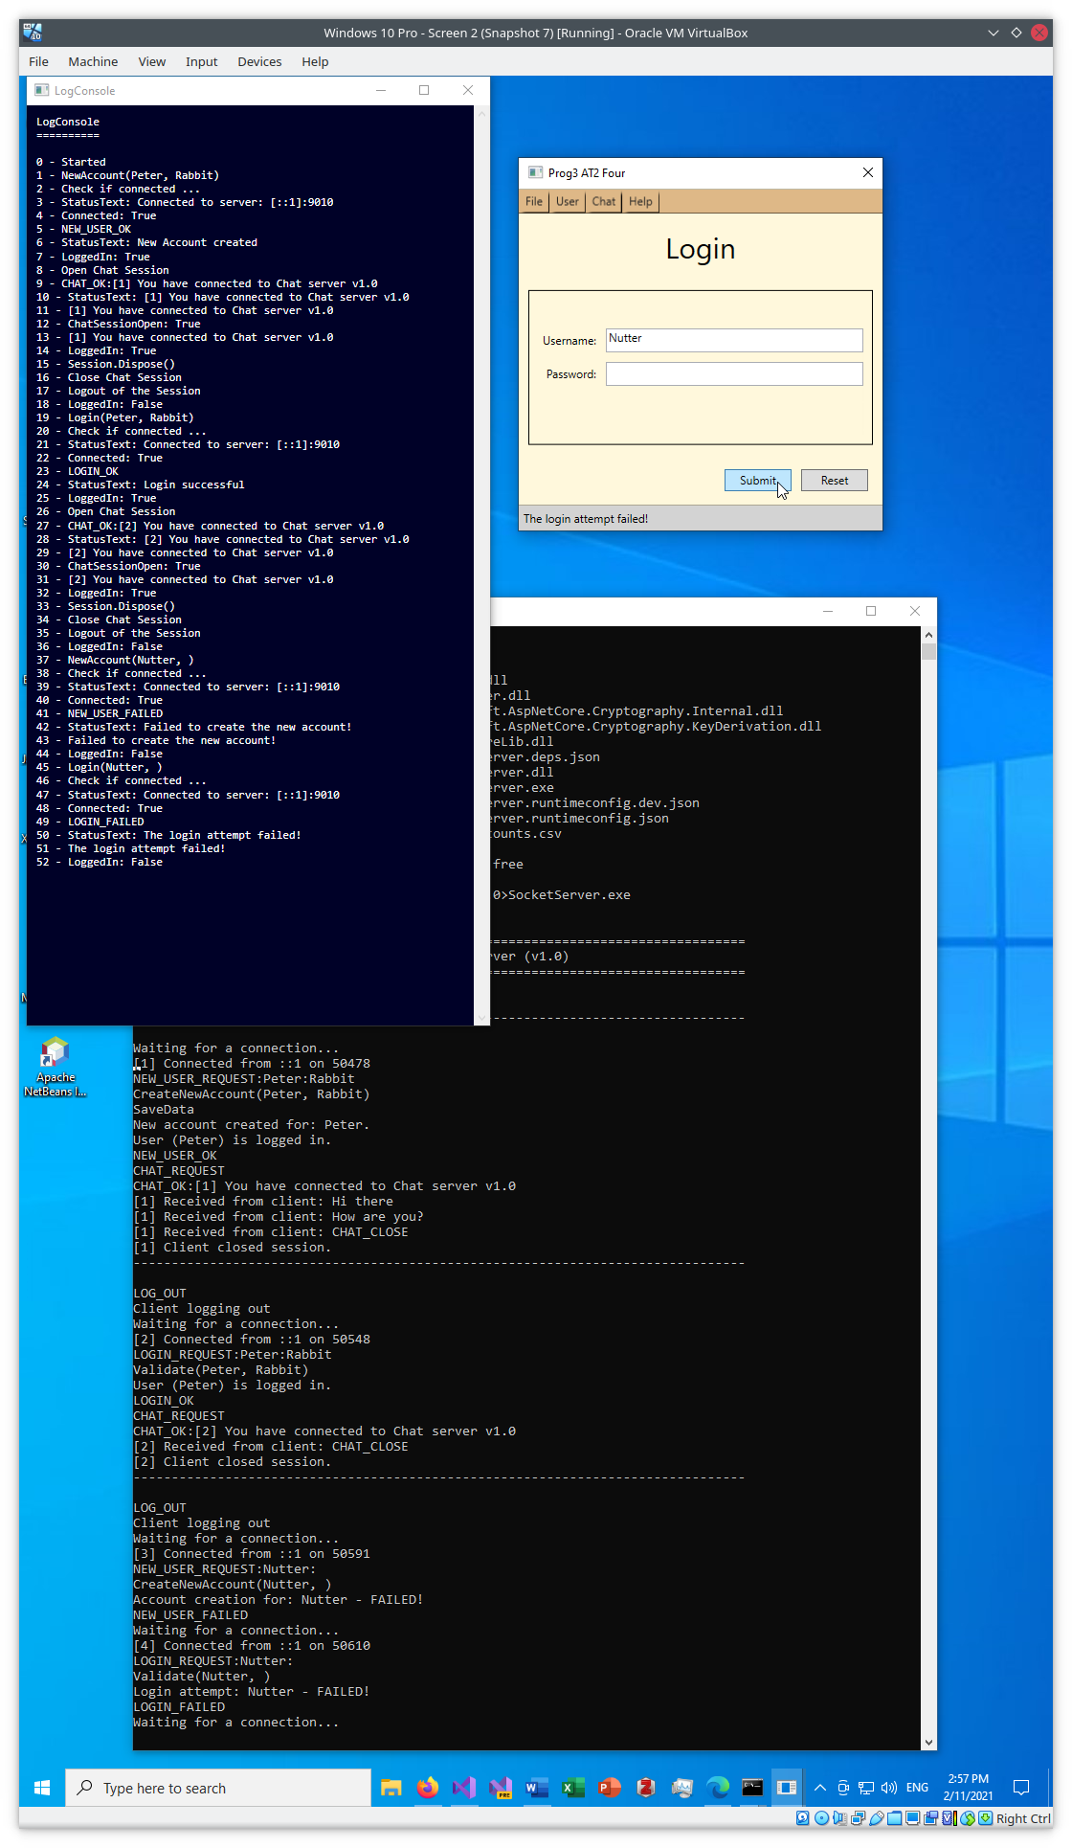

Figure - Try to login as non-existent user – B (Result: Failed)

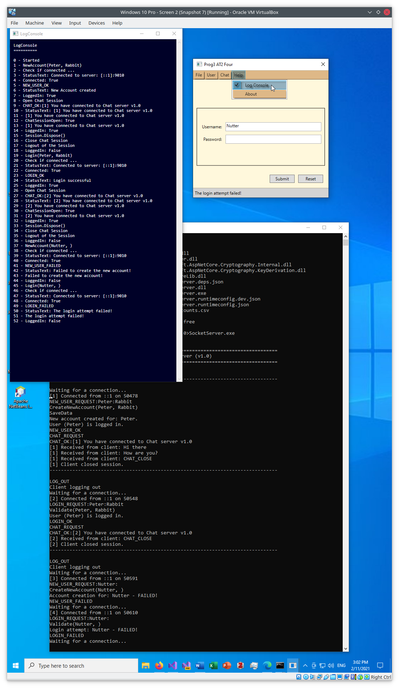

Figure – Help/Log Console – A (Close)

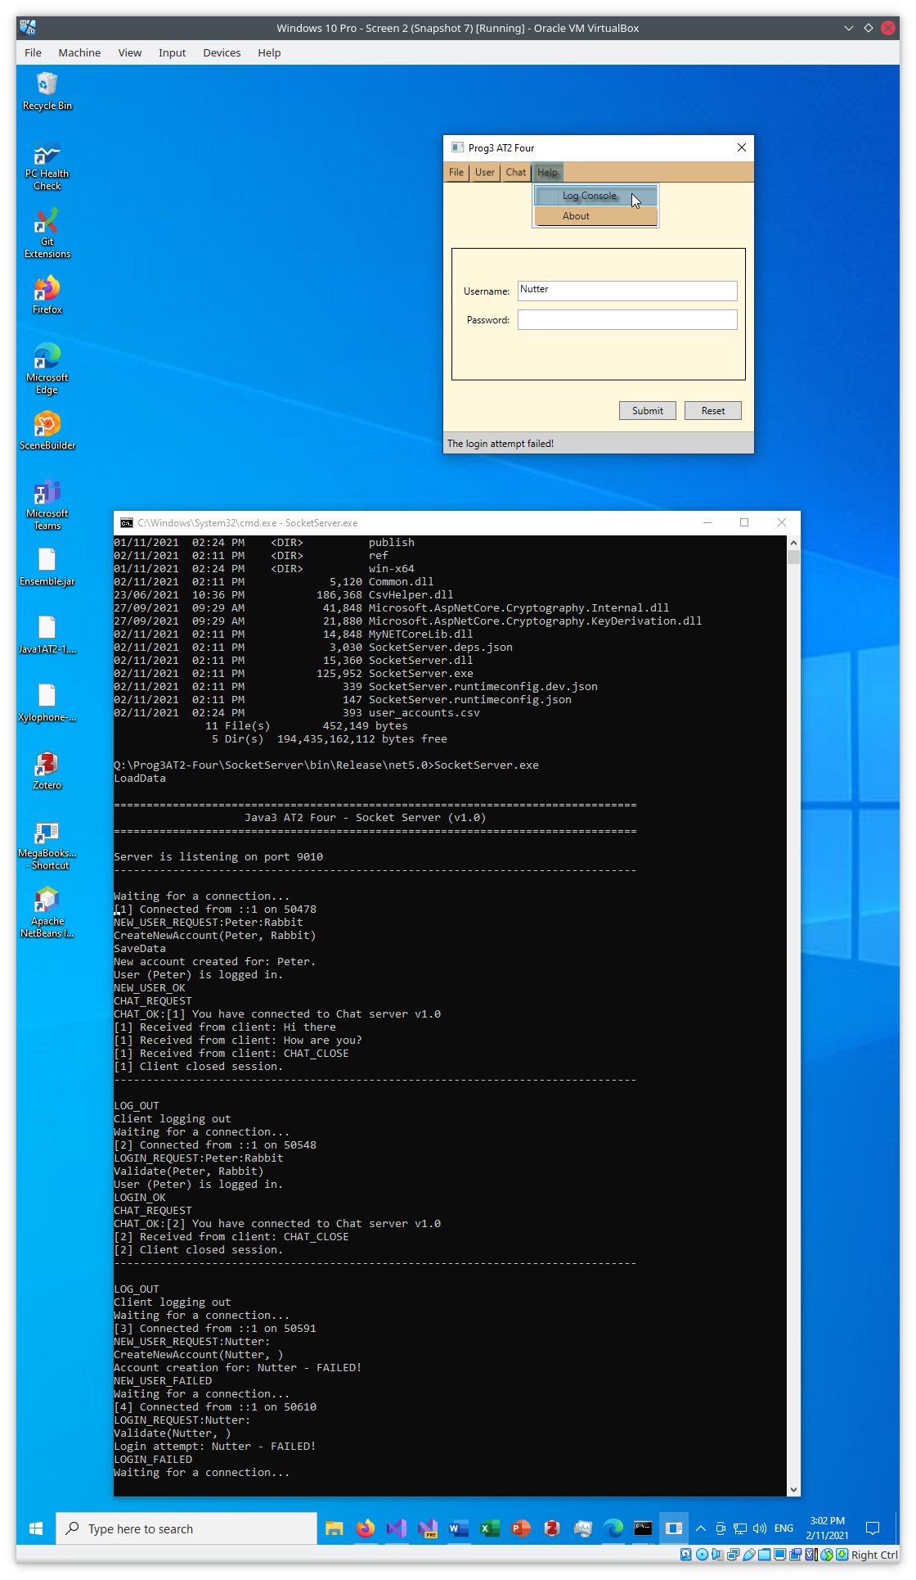

Figure – Help/Log Console - B (Closed)

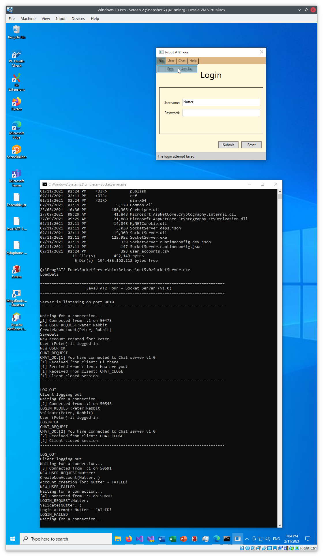

Figure – File/Exit - A

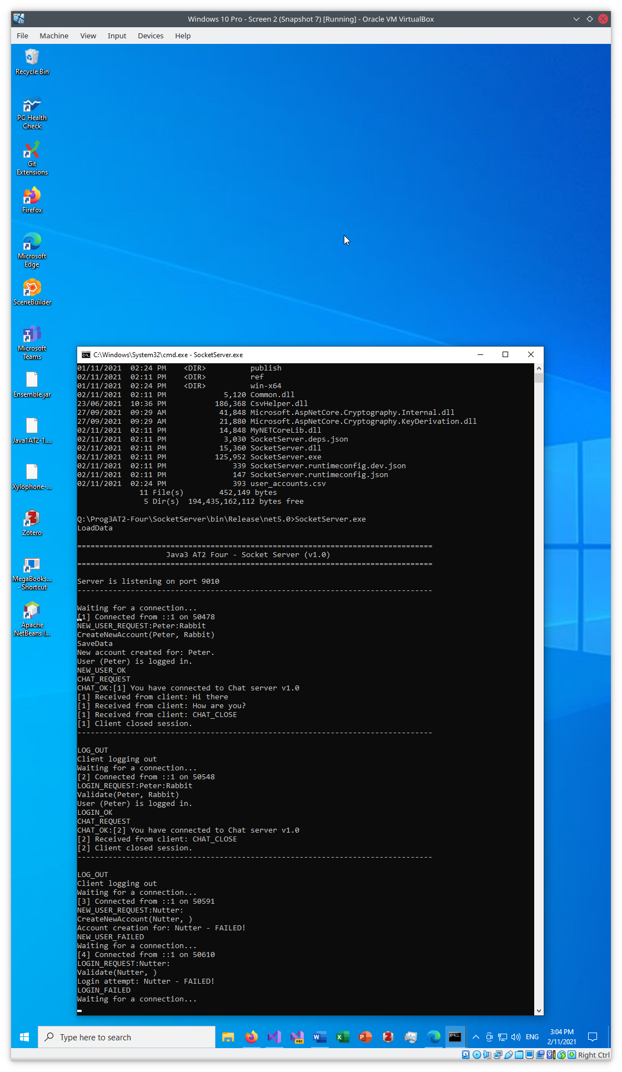

Figure – File/Exit - B (Program shutdown)

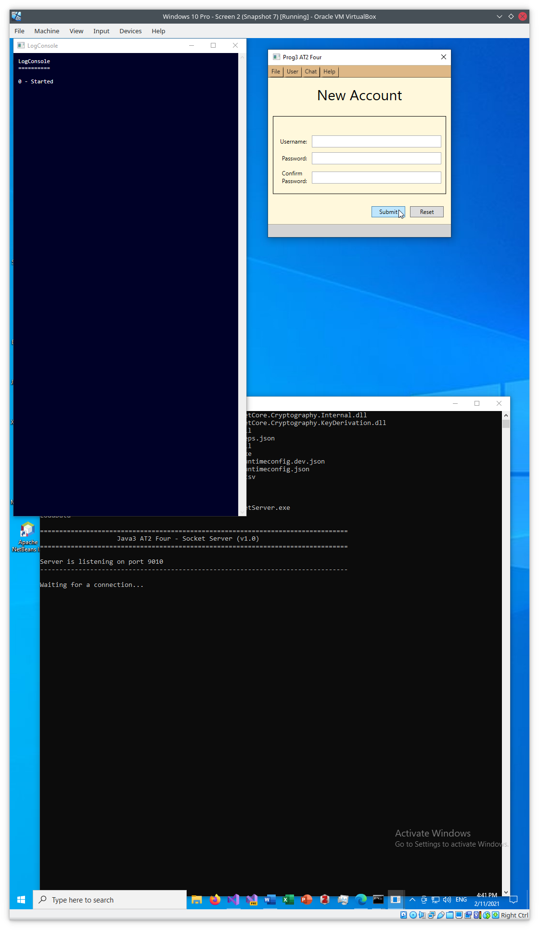

Figure - Submit with blank Username - A

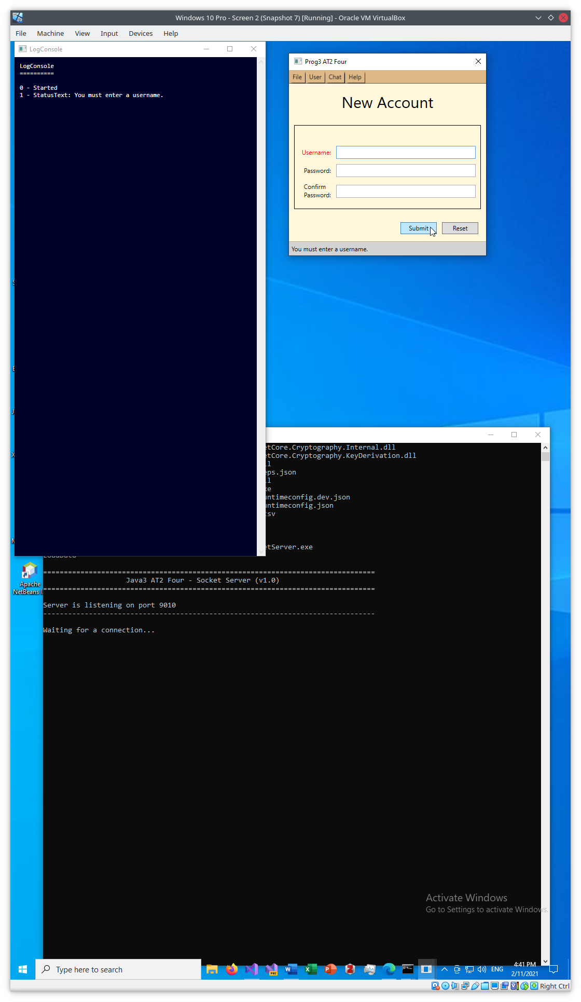

Figure - Submit with blank Username - B (Error displayed)

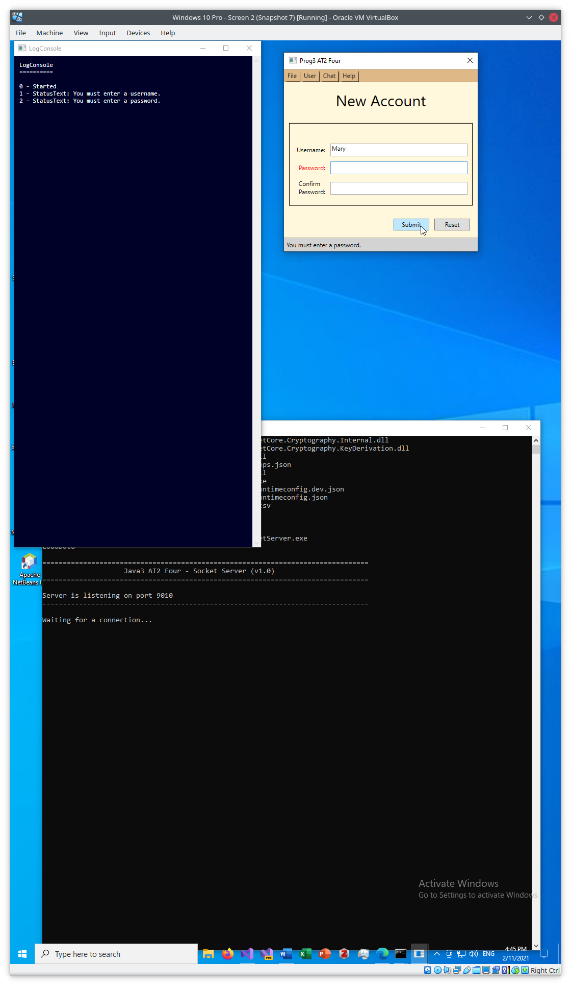

Figure - Submit with blank Password

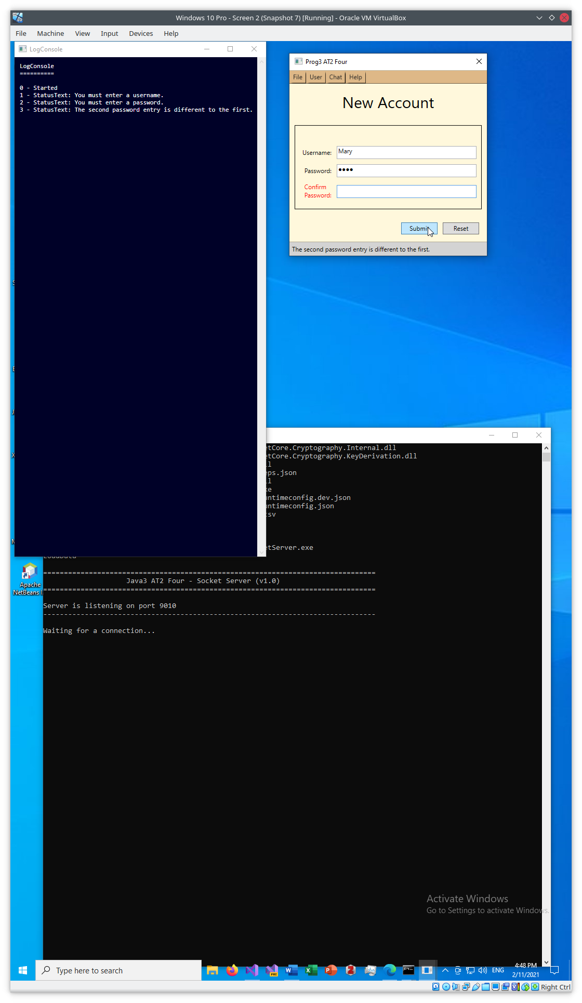

Figure - Password fields don't match - A

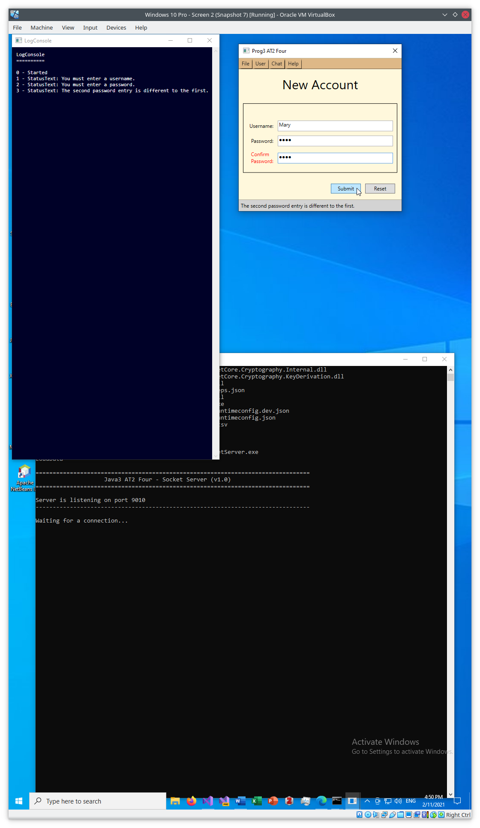

Figure - Password fields don't match - B

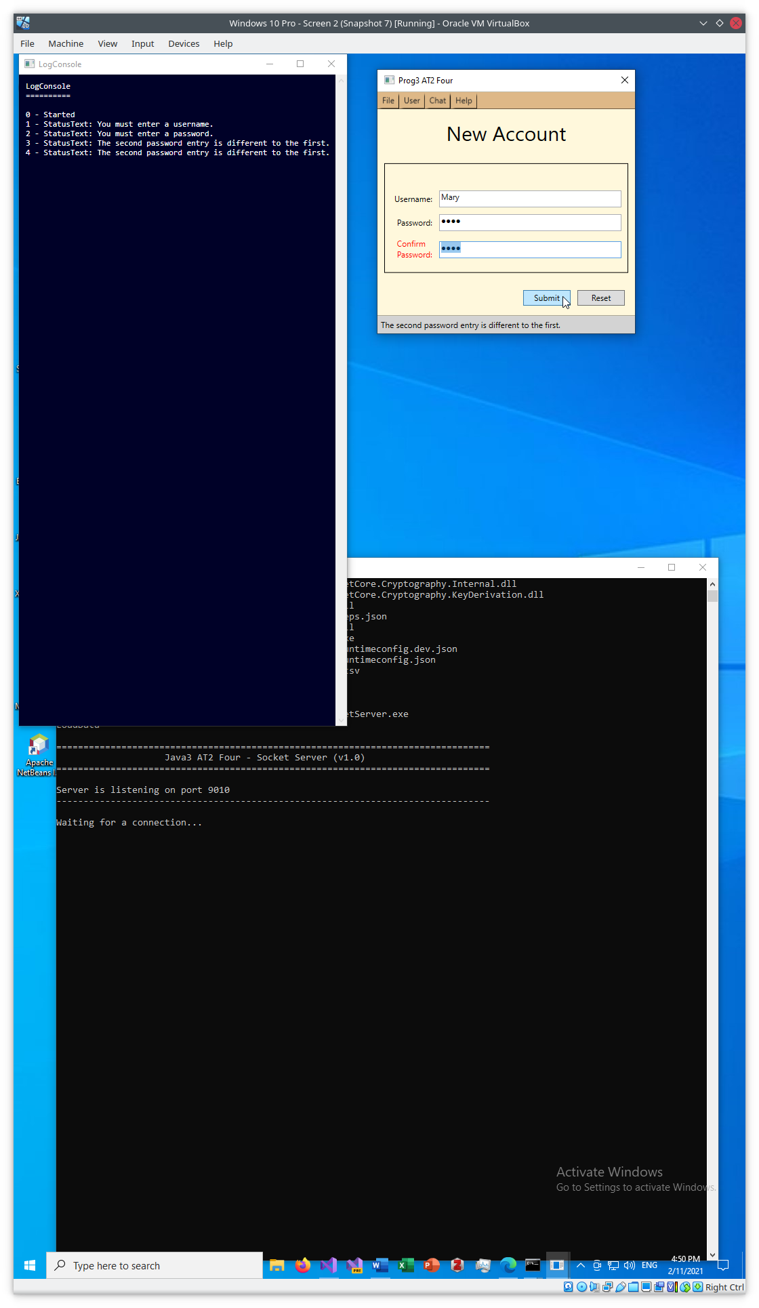

Figure - Password fields don't match - C

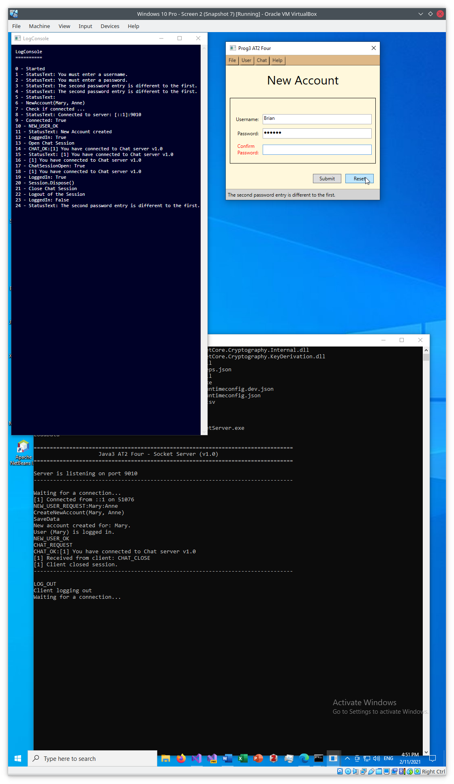

Figure - Use Reset button to clear the form - A

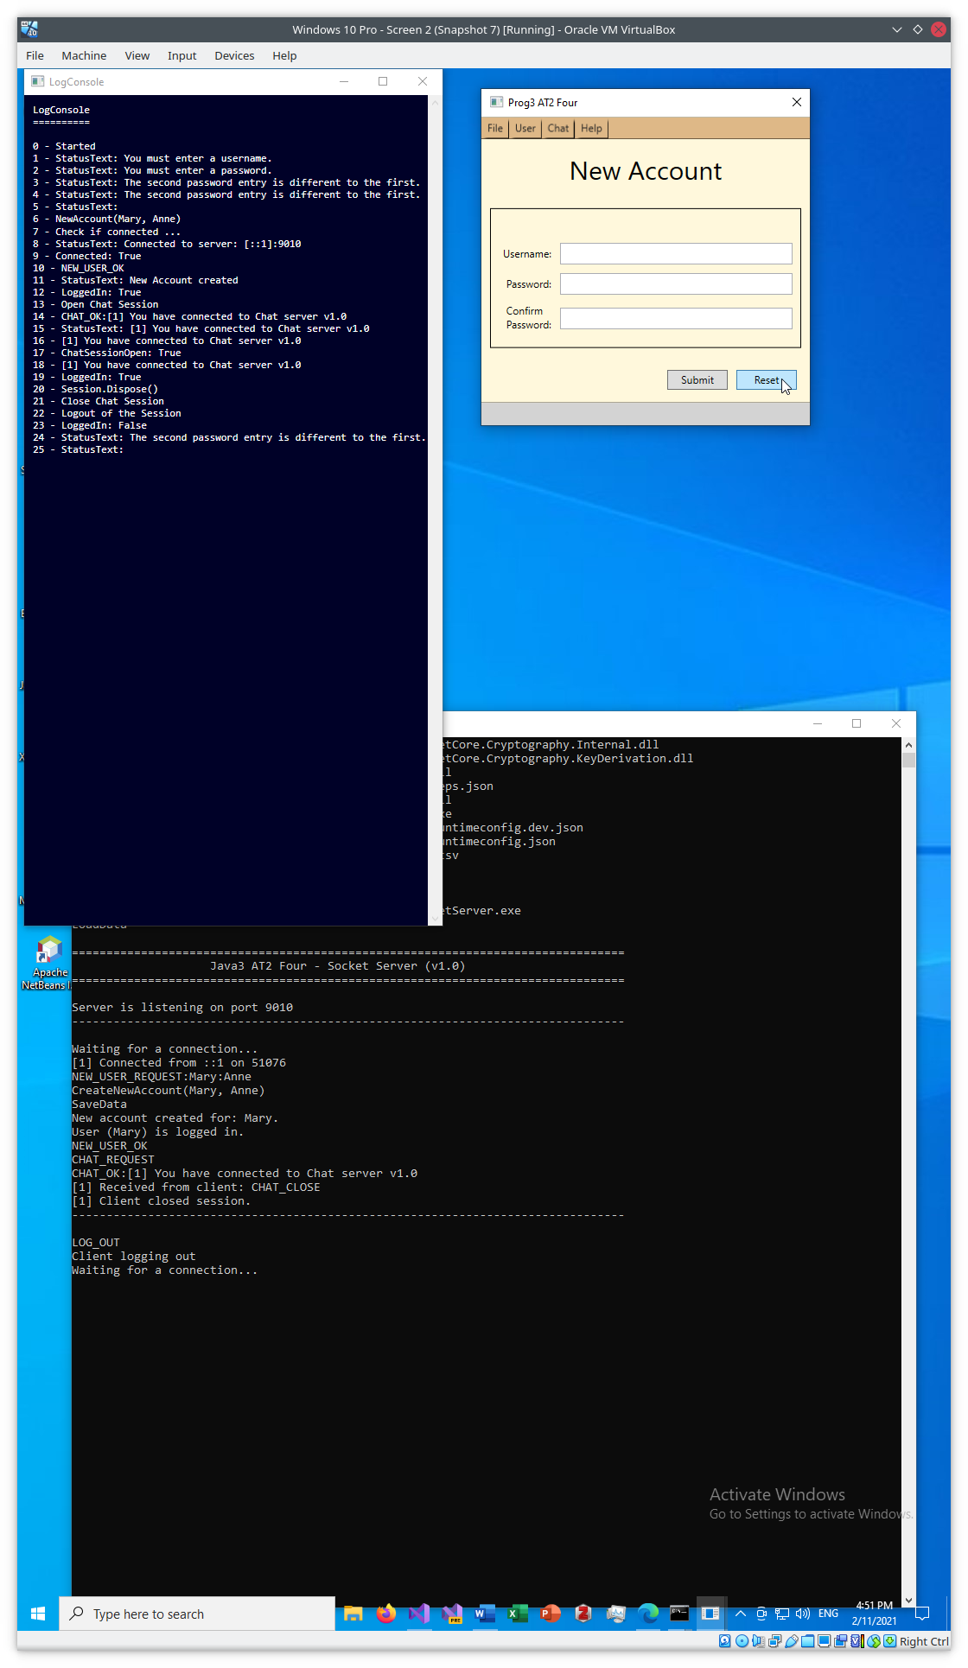

Figure - Use Reset button to clear the form - B

# References